
PRESS RELEASE
COMMUNICATIONS MANAGER
620.252.6115 | atatman@coffeyville.com

June 12, 2026
City of Coffeyville Water Rate Changes take Effect July 1

COFFEYVILLE, KS — During the May 26, 2026, City Commission Meeting, the Coffeyville City Commission approved an updated water rate structure for the City of Coffeyville Water Utility. The new rates will take effect July 1, 2026.
Why are Rate Increases Happening?
The rate adjustment is needed to support increasing operational costs, maintain and replace aging infrastructure, fund future capital improvements, and comply with upcoming federal regulatory requirements.
The City of Coffeyville serves as a regional water provider, supplying drinking water not only to residents and businesses within Coffeyville but also to eight wholesale customers, including Dearing, South Coffeyville, OK, three rural water districts in Montgomery County, one rural water district in Labette County, and one rural water district in Nowata County, OK. The city is also preparing to provide water service to the City of Caney.
"For more than a decade, water rates remained unchanged, while the cost of producing and delivering water has continued to rise," said Director of Public Works Jim Wright. "Inflation, aging infrastructure, equipment needs, future capital improvements, and upcoming federal water regulations have all contributed to the need for additional revenue to maintain and improve the system."
City staff worked with a utility rate consultant to evaluate the actual costs of operating and maintaining the water system and establish rates to help ensure the long-term reliability and feasibility of the City's water infrastructure.
The need for infrastructure investment became especially evident earlier this year when an electrical incident at the Water Treatment Plant highlighted the challenges of operating aging equipment. During a water transmission line project, contractors accidentally struck an overhead electrical line serving the plant. While crews quickly responded and restored operations, aging breakers and electrical equipment created additional challenges and reinforced the need for critical infrastructure improvements.
"What happened at the water plant is exactly what we have been concerned about," said City Manager Ben Brubaker. "These are aging systems, and we cannot continue to delay major infrastructure investments."
Revenue generated through the updated rates will help fund critical water system improvements and support future infrastructure projects needed to maintain reliable service for residents, businesses, and all customers served by the Coffeyville Water Utility.

What Is Changing?
Beginning July 1, 2026, all water customers will transition to a new water rate structure. The new structure consists of two components: a monthly customer charge and a consumption rate. The customer charge helps cover the cost of maintaining the water system and ensuring water is available whenever customers need it. This includes the costs of treatment plants, water lines, storage, pumps, maintenance, and other infrastructure necessary to deliver safe drinking water. The customer charge is determined by meter size and includes the first 1,000 gallons of water used each month. Any consumption above 1,000 gallons will be billed at a flat rate per 1,000 gallons.
Today, customers who use more water pay a lower price per 1,000 gallons than customers who use less water. The new rate structure eliminates that discount. After the first 1,000 gallons included in the base rate, all additional water will be charged at the same rate per 1,000 gallons regardless of total usage. This creates a simpler, more transparent billing system and encourages responsible water use.
As in previous years, customers located outside the city limits will continue to pay higher rates than customers located within the city limits because they do not contribute to the maintenance and replacement of the water system through city property taxes and other municipal revenues.
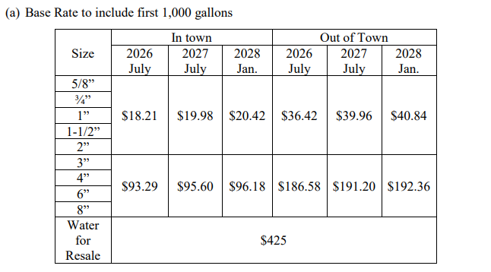
- Customer Charge to include first 1,000 galloons

- For water delivered for consumption within the city limits, per 1,000 gallons or any part thereof:
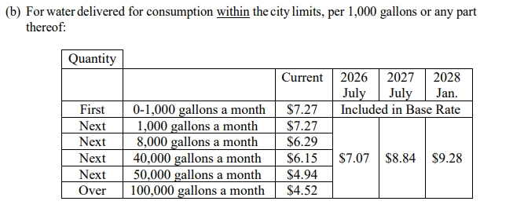
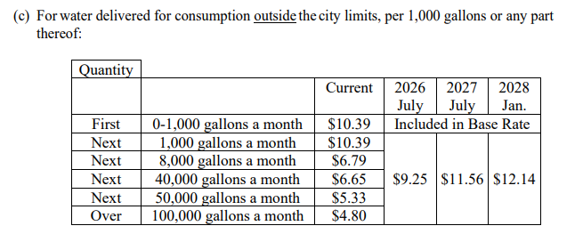
- For water delivered for consumption outside the city limits, per 1,000 gallons or any part thereof:

The average residential customer in town uses about 3,500 gallons per month. The majority of in town residential customers will see their bill increase about $12 a month based on the below rates:
• Customer Charge (includes first 1,000 gallons of water used): $18.21 per month
• Additional Water Consumption: $7.07 per 1,000 gallons
With the new rate structure, the impact on individual bills will vary.. Commercial and industrial customers often have larger meter sizes and higher water usage than residential customers and may have different base rates than those shown above.

When Will I See the New Rates?
The new rates become effective July 1, 2026. Because the City utilizes three utility billing cycles, customers will see their updated rates reflected on different billing statements.
• Cycle 1: Bills issued July 15, due August 5
• Cycle 2: Bills issued July 25, due August 15
• Cycle 3: Bills issued August 5, due August 25
Because July 1 falls within active billing periods, some customers will see a combination of old and new rates on their first bill after July 1.
Additional rate adjustments are scheduled for July 1, 2027, and January 1, 2028. Information regarding those future adjustments will be shared before they take effect.
The City will be releasing additional educational materials in the coming weeks to better understand the new rate structure.
For additional information, contact City Hall at 620-252-6100 or visit www.coffeyville.com.

###

